8-Week Project Logbook — Hand Paralysis Rehabilitation System

WEEK 1: Ideation and Research
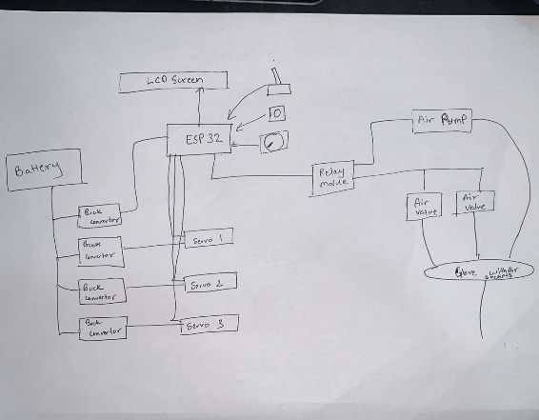
- Identified the rehabilitation gap in existing hand therapy systems — most target only finger motion.
- Defined a goal to design a multi-axis rehabilitation device capable of training both fingers and wrist.
- Finalized the use of ESP32 as the main controller for Wi-Fi and Firebase connectivity.
- Reviewed research on IMU-based rehabilitation devices and studied servo–pneumatic hybrid control.
- Outlined two operation phases — Training (assisted) and Testing (patient-controlled) — for progressive recovery.

WEEK 2: Component Selection and System Architecture
- Selected MPU6050 for real-time motion tracking and 3 metal-gear servos for wrist actuation.
- Added a 12V pneumatic pump and solenoid valve for finger movement using air pressure.
- Designed hardware architecture including toggle switch, mode button, and potentiometer for user input.
- Verified component voltage and current ratings to ensure stable operation.
- Created the initial block diagram and system layout integrating mechanical, electrical, and cloud layers.

WEEK 3: Circuit Design and Basic Control Setup
- Developed the complete wiring schematic for ESP32, servos, IMU, pump, and valve.
- Implemented independent 5V and 12V power rails with common ground for clean actuation signals.
- Wrote initial Arduino test code for servo rotation and IMU angle reading.
- Verified stable I²C communication between ESP32 and MPU6050.
- Successfully controlled pump inflation/deflation using a MOSFET driver and tested manual actuation.
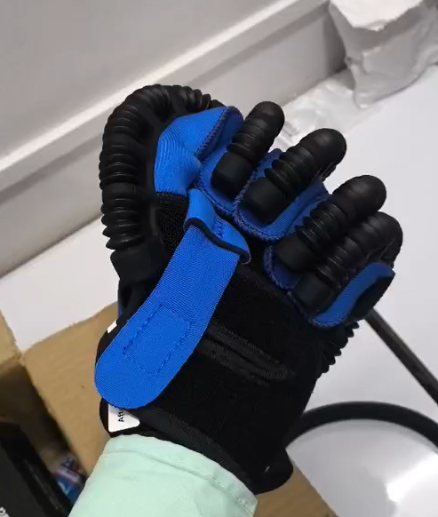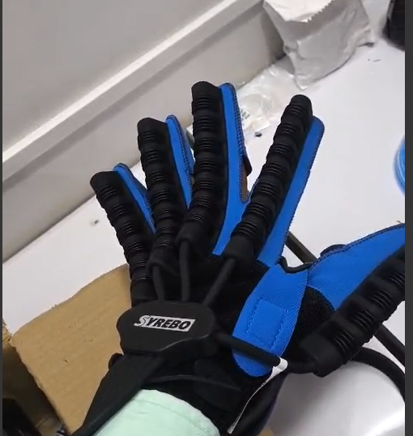

WEEK 4: Control Logic and Phase Integration
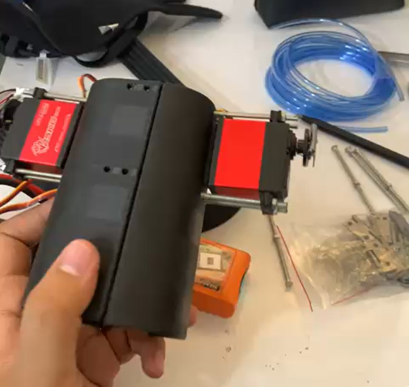
- Implemented Training Phase: servo and pneumatic control loops for guided exercises.
- Added Testing Phase: IMU-only data acquisition with actuators disabled.
- Programmed Wi-Fi and Firebase Realtime Database communication using Firebase ESP32 Client.
- Data uploaded successfully in JSON format with timestamp, mode number, and angle readings.
- Calibrated the IMU to remove drift and verified consistent angular readings over time.

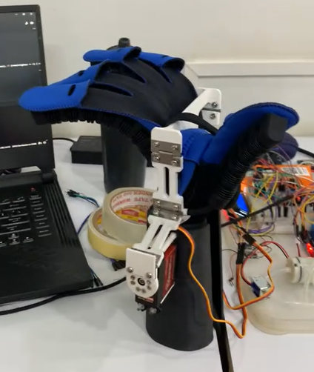
WEEK 5: Multi-Mode Motion and User Interface
- Programmed three distinct motion modes:
1️⃣ Finger folding/unfolding (pneumatic module)
2️⃣ Wrist flexion/extension (servo-based)
3️⃣ Wrist ulnar/radial deviation (servo-based)
- Added LCD (16x2) for displaying phase, mode, and repetition count.
- Created button-based switching between Training and Testing phases.
- Fine-tuned servo PWM values for smooth, human-like motion transitions.
- Completed first integrated hardware prototype and verified all motion modes.

WEEK 6: Data Logging and Analytics
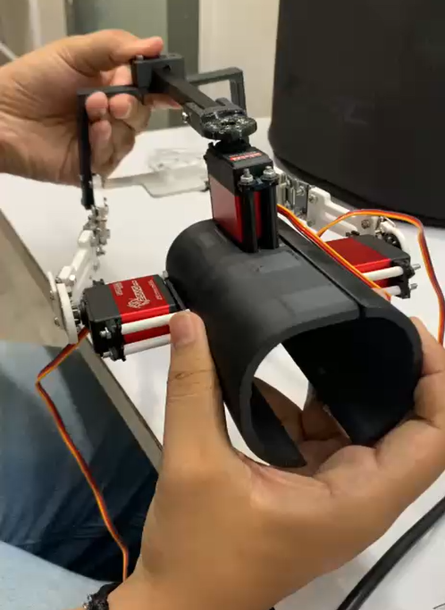
- Validated continuous Firebase uploads — angle, session ID, repetition, and timestamp per second.
- Built Python scripts using pandas and NumPy for reading session data and cleaning noise.
- Computed Range of Motion (ROM) = max(angle) - min(angle) for each session.
- Implemented Linear and Polynomial Regression models in scikit-learn to track improvement trends.
- Plotted session-wise progress using matplotlib, confirming visible recovery progression.
- Made Changes to the existing design due to various flaws and complexities.

WEEK 7: GUI Development and Predictive Modelling
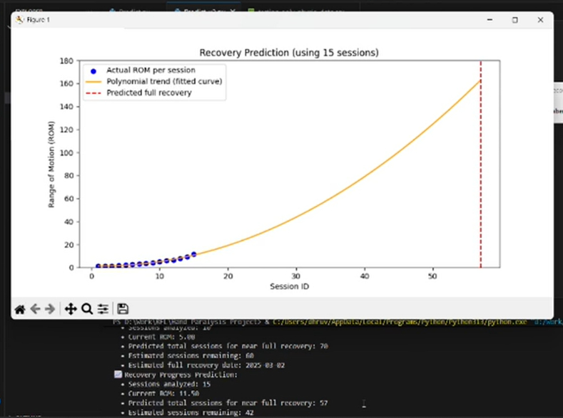
- Developed Tkinter GUI for physiotherapist interface.
- Added “Analyze Data”, “Predict Progress”, and “Export Report” buttons.
- Displayed ROM improvement graphs and prediction curves from regression models.
- Integrated LSTM model for time-series prediction of recovery trends.
- Validated GUI output with real Firebase datasets — ensured smooth end-to-end operation.

WEEK 8: Testing, Validation, and Final Optimization
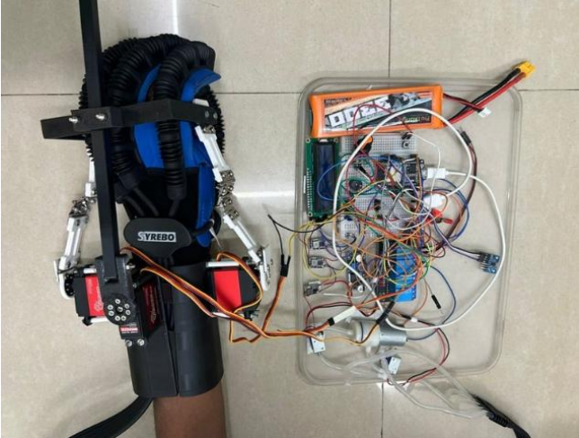
- Conducted complete hardware–software integration testing.
- Evaluated accuracy of IMU tracking during both assisted and voluntary motion.
- Ran continuous rehabilitation cycles to ensure safety, smoothness, and mechanical durability.
- Verified Firebase synchronization and GUI visualization under real operation.
- Received expert feedback (physiotherapists and Bionics Innovations) suggesting improved wrist motion coverage.
- Finalized documentation and testing videos for evaluation and IRIS submission.

